6U 400MM 19" DATA WALL CABINET - 6U NETWORK CABINET BLACK
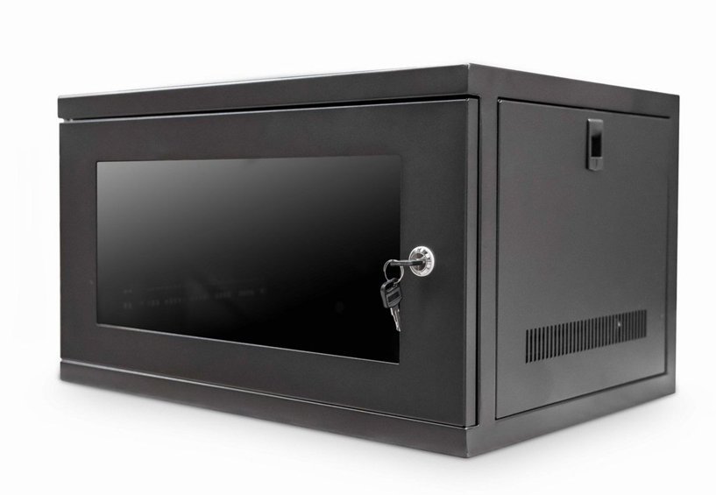

DESCRIPTION
The new CAB-W6U-EL400 is a feature rich, 6U wall mount cabinet that allows all
networking, PBX, A/V and home automation to be installed within its
universal standard 19-inch vertical support rails.
With an extra 400mm deep form-factor, the majority of entry to
medium range networking hardware can be installed with ease, as well of course
passive networking hardware including patch panels, cable management, PDUs
and even rack-mount fan trays.
Fully built straight from the box, the CAB-W6U-EL400 6U Network Cabinet features a front reversible lockable door, removable side panels for ease of
equipment access and rear vertical profiles for secure equipment fixing.
Equipped with ventilation slots for increased equipment airflow and of course
easy, single person installation makes the CAB-W6U-EL400 the ideal choice for all
your SME installations.

TECHNICAL SPECIFICATIONS
6U high 550W 400D
ETSI 19” front/rear profiles
Lockable glass door, reversible if required
Wall mountable with removable side panels
Power-coated BLACK and robust grey finish
Easy-to-install wall deployment - pre built
Supplied with a bag of M6 fixings

PRODUCT INFO
SKU/MPN: CAB-W6U-EL400
EAN: 8400800025302
Weights: 10.1Kg
Dimensions: 550(width) x400(depth) x320mm (height)

FILES
Datasheet - CAB-W6U-EL400

